Software Specification Document

OpenOffice
In the word processor program, insert diagonal table header into the first cell of the table.

Specification Status
Last Change | July 10 2007
Status
Abstract
OOo does not provide the feature of inserting diagonal table header, the user will meet the following problems when they use drawing tool to draw diagonal line in the cells to achieve that feature, the diagonal line won't be changed if the size of the cell changes, if the client wanna input word at the part of diagonal line he can only do so by using self chosen text frame to input word which will be very inconvenient, so we can meet user's need by inserting diagonal line table header that is to combine inserting diagonal line with inputing word to fulfill the function of inserting diagonal line table header, we can add "insert diagonal line table header " menu item in the main menu “Insert" and at the same time we can build a box called" inserting clined line table header". the box of " inserting clined line table header is used to provide the customer with the function of choosing clined line table header format, inputing word and choosing the font size of the word.
i-Team Members
Role | First Name, Last Name, Initials | E-Mail Address
Project Lead | <First Name, Last Name (Initials)> | <User@openoffice.org>
Specification Owner | <First Name, Last Name (Initials)> | <User@openoffice.org>
User Experience | <First Name, Last Name (Initials)> | <User@openoffice.org>
Development | <First Name, Last Name (Initials)> | <User@openoffice.org>
Quality Assurance | <First Name, Last Name (Initials)> | <User@openoffice.org>
Documentation | Zhoubo Shi | shizhoubo@ch2000.com.cn
Other roles | <First Name, Last Name (Initials)> | <User@openoffice.org>
<State reason here, if one role is not represented in i-Team.>

Contents
Abstract 1
i-Team Members 1
References and Reference Documents 3
Acronyms and Abbreviations 4
1 Detailed Specification 5
2 Migration 7
3 Configuration 7
4 File Format 8
5 Open Issues 8
Document Change History 8

References and Reference Documents
Reference Document | Check | Location (URL)
Specification Process Entry Check |  | N/A
Product Requirement,, RFE, issue (required) |  | <Please enter location here>
Product Concept Document |  | <Please enter location here>
Competitive Analysis |  | <Please enter location here>
Test Case Specification (required) |  | <Please enter location here>
Software Specification Rules | N/A | N/A
<Other, e.g. references to related specs>

Acronyms and Abbreviations
Acronym / Abbreviation | Definition
<WYSIWYG> | <What You See Is What You Get>

Detailed Specification
In OpenOffice version 2.1 there isn't the feature of insering diagonal table header: the feature is to draw a diagonal line or two diagonal lines in the cell, and divide the cell into two or three subcolumns, these subcolumns can be input some words to confirm the content of the subcolumns; only can through using the drawing tools to draw diagonal line in the cells, diagonal line won't change by the changes of cell height or width. See below:
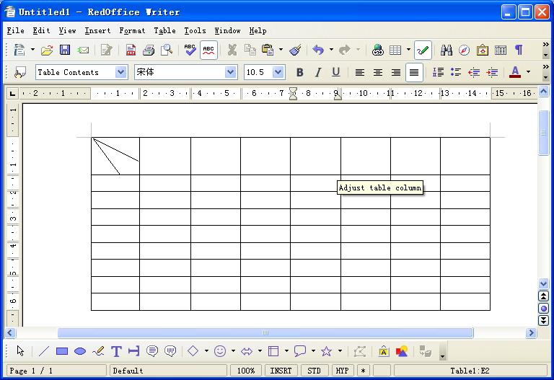
Figure 1: through using the drawing tools to draw diagonal line in the cells.
Diagonal line won't be changed by the changes of cell size, for instance: height or width, See below:

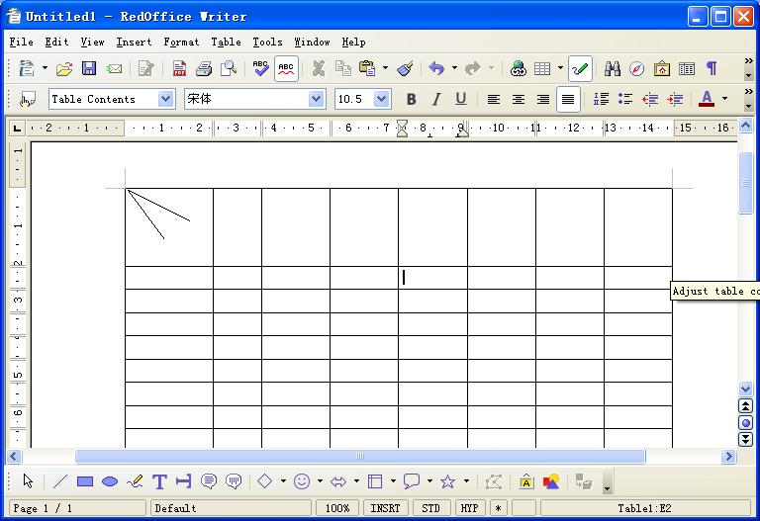
Figure 2: diagonal line won't be changed to fit the the changes of cell's width.
at the same time if the user wanna input word at the three parts divided diagonal line, he can only do so by using self chosen text frame to input word.
Figure 3: When the client wanna input word at the part of diagonal line he can only do so by using self chosen text frame to input word which will be very inconvenient. See below:
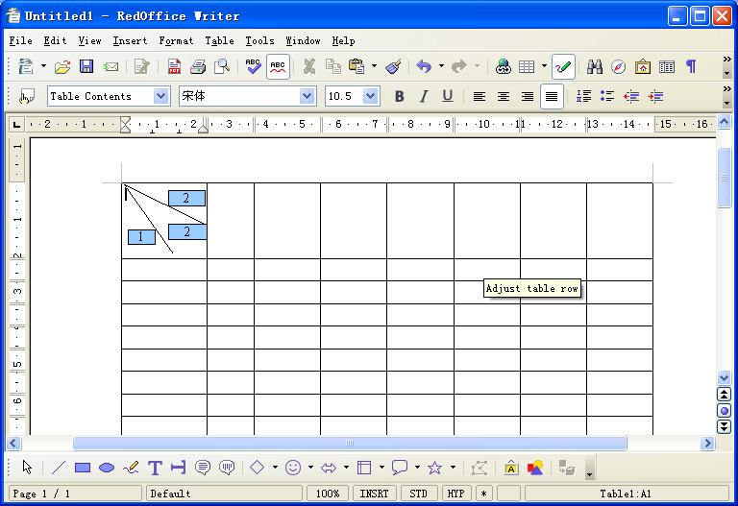

The idea:
User Interface analysis
Add "diagonal table header" to the menu bar:
In the word processor program, add the menu item called "diagonal table header" into the main menu of "insert", the location of the menu is below
Figure 4: the menu location of "diagonal table header"; See below:

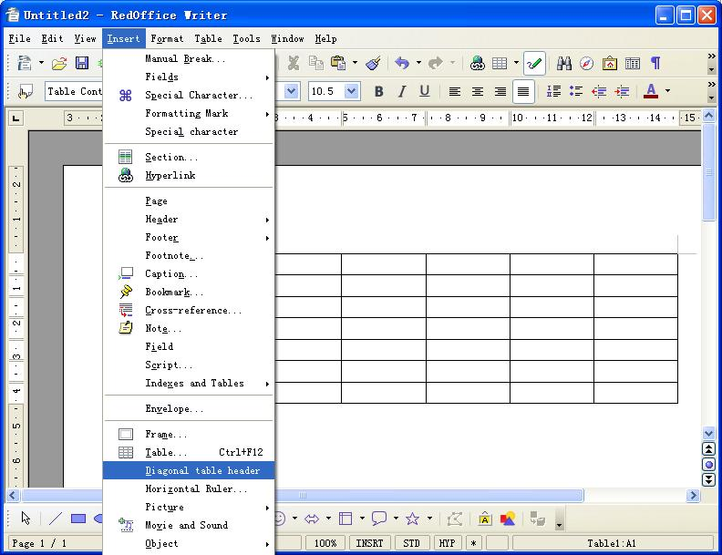
Menu introduction: if the current document doesn't have table or the first cell was protected, the menu item of "diagonal table header" was disabled and it was gray; if the current document have a table, the menu of "diagonal table header" was enabled; the event of this menu is to create a dialog box of "diagonal table header".
the dialog box of "diagonal table header": this dialog box was used to configure the dialog box of diagonal table header by user, it supply 14 diagonal line styles and 30 font sizes to the user、writing input. The user interface operation below:

8  6  1 | 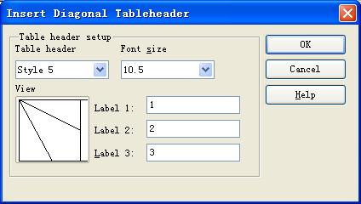 | 10  11  12  4  5  3  2  9  7
Figure 5: the dialog box of "insert diagonal table header" was configured by user

Table 1: User Interface elements of Figure 5
# | Type | Properties |  | Comment
1 |  | Control Properties  State: Modal  Closable: Yes  Resizable: No  Always On Top: Yes  A11Y Text: None  Other...: None |  | the dialog box of insert diagonal table header is a mode window, it's size can't be changed and it show always on the top of the layer.
1 |  | String English  N/A | String German  N/A
2 |  | Control Properties  Enabled: Yes  Maximum Row Count: 14  Visible Row Count: 7  Initially Selected Item: 1  ToolTip Text: None  A11Y Text: None  Other...: None |  | this is a combo box and it contain 14 diagonal line types to supply for user, select the first one when it is initialized.

3 |  | Control Properties  Features: picture preview box |  | this control can browse and show the picture, it can be changed by the selection of the combo box, when user select the different type of the diagonal line, it can show the picture selected by the user.
3 |  | String English  N/A | String German  N/A
4 |  | Control Properties  Enabled: Yes  Editable: Yes  Initial Text Inside Field: None  Drag Enabled: No  Initial Caret Position: 0  KeyMap: Default KeyMap |  | this is text editor box, it edits words of the first diagonal table header was inserted by user
4 |  | String English  N/A | String German  N/A

5 |  | Control Properties  Enabled: Yes  Editable: Yes  Initial Text Inside Field: None  Drag Enabled: No  Initial Caret Position: 0  KeyMap: Default KeyMap | this is text editor box, it edits words of the second diagonal table header was inserted by user

6 |  | Control Properties  Enabled: Yes  Editable: Yes  Initial Text Inside Field: None  Drag Enabled: No  Initial Caret Position: 0  KeyMap: Default KeyMap |  | his is text editor box, it edits words of the third diagonal table header was inserted by user
6 |  | String English  N/A | String German  N/A

7 |  | Control Properties  Enabled: Yes  Maximum Row Count: 30  Visible Row Count: 7  Initially Selected Item: 6  ToolTip Text: None  A11Y Text: None  Other...: None |  | this is combo box, it contains 30 font sizes to select, the range of the font size as the same of the word processor program, the original font size is 10.5 point, also is the 6th item.
7 |  | String English  N/A | String German  N/A

8 |  | Control Properties  Enabled: Yes |  | this is a static label, it is the introduction for the font size
8 |  | String English  N/A | String German  N/A

9 |  | Control Properties  Enabled: Yes |  | this is a static label, it is the introduction for the diagonal line style.
9 |  | String English  N/A | String German  N/A

10 |  | Control Properties  Enabled: Yes  Icon: No  Resizeable: No  Has Menu: No |  | this is a button, after user finish setting of type and size of the word for diagonal line, click this button, and the diagonal line choosen by user will be insertted into the first table.
10 |  | String English  Yes | String German  N

11 |  | Control Properties  Enabled: Yes  Icon: No  Resizeable: No  Has Menu: No |  | this is a applications button, when the user wanna insert diagonal line, click this button, the program can implement the operation of inserting diagonal table header,and then close the dialog box.
11 |  | String English  Yes | String German  N

12 |  | Control Properties  Enabled: Yes  Icon: No  Resizeable: No  Has Menu: No |  | This is a help button, click this button will get the help information.
12 |  | String English  Yes | String German  N
The above is the introduction of configuring "insert diagonal table header",when user click the button of "confirm",insert different diagonal line into table in accordance with the different type of diagonal line table header chosen by user.

table header styles analysis
Now let's analyse the list of 14 diagonal line styles, these 14 diagonal line styles are divide into two classes, the first class only has one diagonal line with two styles, the second has two diagonal lines with 12 styles.
The first class only has one diagonal line
one diagonal line, See below:
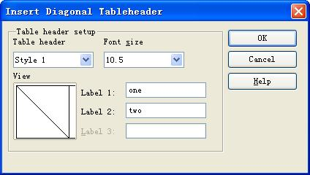
Figure 6: diagonal style is from the top left corner to the bottom right corner of the cell.
Anouther one diagonal line, See below:
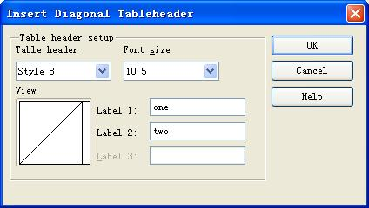
Figure 7: diagonal style is from the bottom left corner to the right right corner of the cell.
explanation : when the user select the style only has one diagonal line, it can divide the cell into two parts, so it can only input two words introduction, the third title was shown gray, that express it doesn't need the third title. Put this style into top left corner of the first cell in the table. See below:
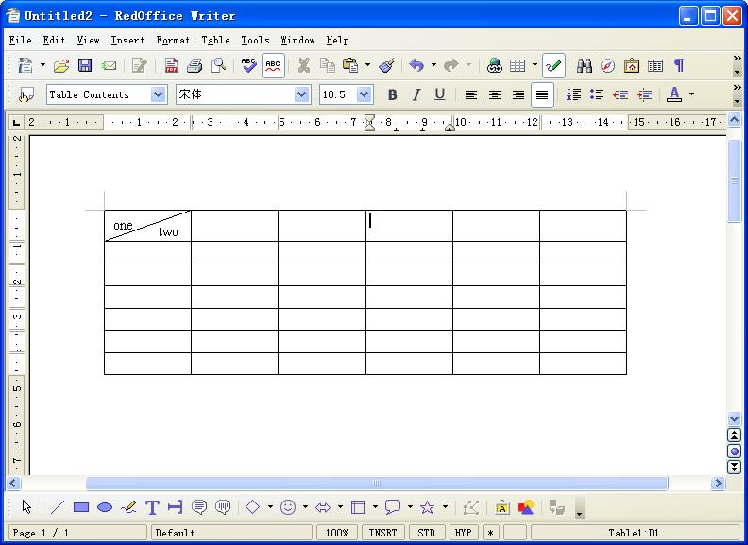
Figure 8: Preview image

The second type has two diagonal line
Type A :
two diagonal line start from any angle of the cell and end at the the other side of the cell, so there will be four types in all if we calculate like this, See below:
Style 2 | style 5 | style 9 | style 12
when the user select the style 2 in the Pull-Down list box named table header, the preview box
will show the diagonal line was style, see below:
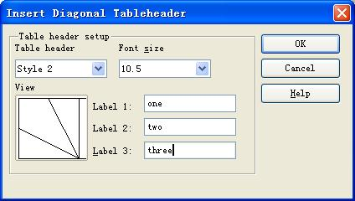
Click “OK”Button, preview image Below:
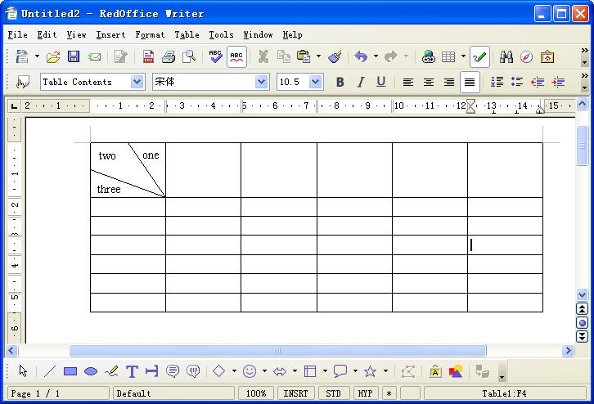
Type B:
two diagonal line start from any angle of the cell one ends at the other side of the starting point and the other line ends at the any other angle of the cell and there will be 8 types under this calculation, See below:
Style 3 | Style 4 | Style 6 | Style 7 | Style 10 | Style 11 | Style 13 | Style 14
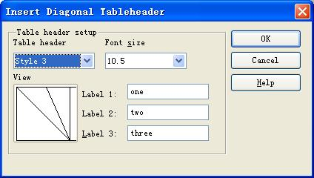
when the user select the style 3 in the Pull-Down list box named table header, the preview box will show the diagonal line was style 3, see below:
Click “OK”Button, preview image Below:

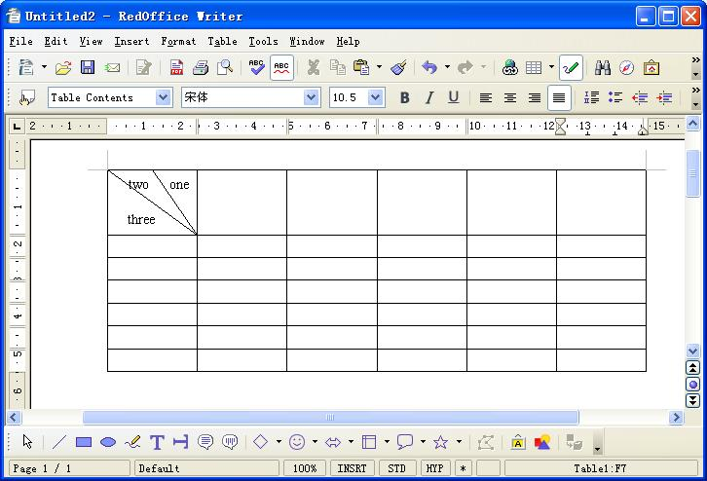

Before change the Cell's height

operation analysis
1.) When change cells' height or width, two end-points of the diagonal line in the diagonal table header are consistent with the location of the cell border contact-point:
Example a: before not change the cells's height or width, See Below:
image a

After change cell's height

b After change the cells's height, See Below:
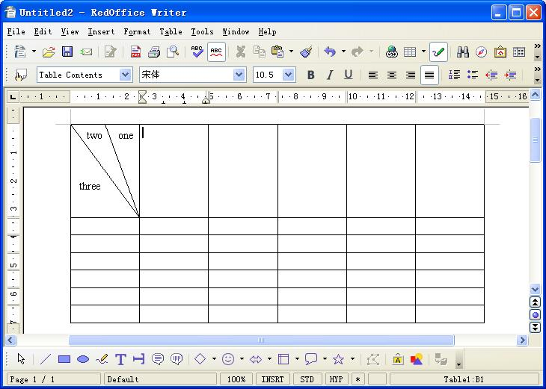
image b
When change cells' height, two end-point of the diagonal line in the diagonal table h eader are consistent with the right down point of the cell.

2、Hange the connection location of the selected diagonal line, See the model below:
a before chage the line location, see bolew:
Before change the line loacation
b after chage the line location, see bolew:
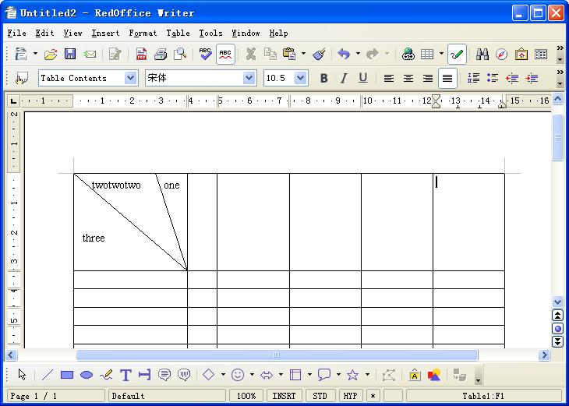
After change the line location
3、edit the content by double clicking the Text and change the text location.
A: Edit the content by double clicking it. See below modify the characters "three":
 | 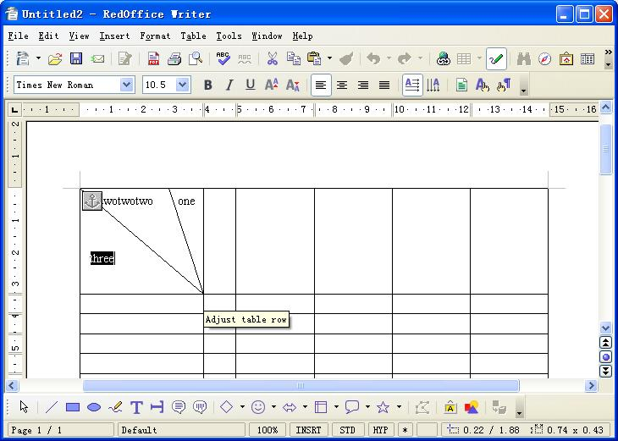 | Before the text change

B : change the characters "three" into the characters "Table", See below:
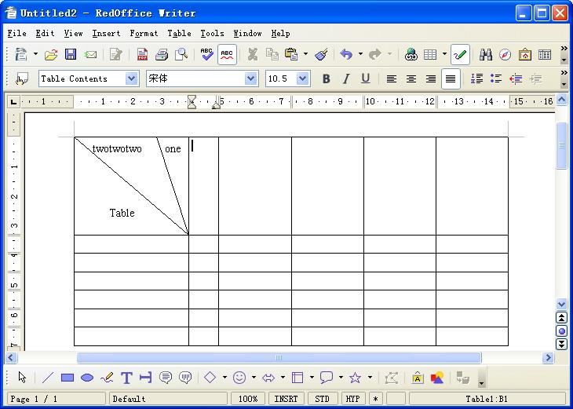
After change the text

4、Diagonal table header support the repeated operation to heading line;
when the table extends from the current page to the next,insert diagonal table header at the first page and then repeat the operation of heading the diagonal table header will be applied to the
first table line of each page.

Migration
<Start typing here ----- If this part is irrelevant state a reason for its absence!>

Configuration
<Start typing here ----- If this part is irrelevant state a reason for its absence!>

File Format
<Start typing here ----- If this part is irrelevant state a reason for its absence!>
Change to the file format
File | Section | Comment
content.xml | ooo:body-text-table-row-cell- | the content for document format has been changed in content.xml, under  "body-text-table-row-cell" Schema, the following are added  a) draw::roline, this role schema indicates diagonal line is needed  b) draw::rotex, this rotext schema indicates that text box is needed  the two schemas compose diagonal line table header
Open Issues
Issue | Initials | Date
<State Issue here, State “None”, if all issues are solved> |  | <Format: Dec 31, 2000>
<...>

Document Change History
Rev. | Change | Initials | Date
1 | Create |  | July 10 2007
2
3
<...>

