

Getting Started Guide
Chapter 1
Introducing OpenOffice.org

This PDF is designed to be read onscreen, two pages at a time. If you want to print a copy, your PDF viewer should have an option for printing two pages on one sheet of paper, but you may need to start with page 2 to get it to print facing pages correctly. (Print this cover page separately.)

Copyright
This document is Copyright © 2005–2010 by its contributors as listed in the section titled Authors. You may distribute it and/or modify it under the terms of either the GNU General Public License, version 3 or later, or the Creative Commons Attribution License, version 3.0 or later.
All trademarks within this guide belong to their legitimate owners.
Authors
Thomas Astleitner Richard Barnes
Agnes Belzunce Daniel Carrera
Laurent Duperval Ian Laurenson
Alan Madden Carol Roberts
Iain Roberts Gary Schnabl
Janet M. Swisher Jean Hollis Weber
Linda Worthington Michele Zarri
Feedback
Please direct any comments or suggestions about this document to: authors@documentation.openoffice.org
Publication date and software version
Published 16 January 2010. Based on OpenOffice.org 3.2.
Contents
Copyright 2
What is OpenOffice.org? 5
Writer (word processor) 5
Calc (spreadsheet) 5
Impress (presentations) 6
Draw (vector graphics) 6
Base (database) 6
Math (formula editor) 6
The advantages of OpenOffice.org 7
Minimum requirements 8
How to get the software 8
How to install the software 9
Extensions and add-ons 9
How to get help 9
Help system 9
Free online support 9
Paid support and training 10
Starting OpenOffice.org 11
Note for Mac users 11
Starting from an existing document 11
Note for Windows users 11
Using the Quickstarter under Windows 12
Using the Quickstarter icon 12
Disabling the Quickstarter 12
Reactivating the Quickstarter 13
Using the Quickstarter in Linux 13
Preloading OOo under Linux/KDE 13
Starting from the command line 13
Parts of the main window 15
Menu bar 15
Toolbars 16
Displaying or hiding toolbars 16
Submenus and tear-off toolbars 16
Moving toolbars 17
Floating toolbars 17
Docking/floating windows and toolbars 17
Customizing toolbars 18
Right-click (context) menus 19
Status bar 19
What are all these things called? 20
Starting a new document 21
Opening an existing document 22
Saving documents 22
Password protection 23
Saving a document automatically 23
Renaming and deleting files 24
Using the Open and Save As dialogs 24
Using the Navigator 25
Undoing and redoing changes 27
Closing a document 28
Closing OpenOffice.org 28

What is OpenOffice.org?
OpenOffice.org (OOo) is both a software product and a community of volunteers who produce and support the software.
Note | Because someone else owns the trademark OpenOffice, the correct name for both the open-source project and its software is OpenOffice.org.
The OpenOffice.org software is a freely available, full-featured office productivity suite.
OOo 3.0 was a major upgrade of an already feature-rich office suite, and later releases have added more features. If you have used previous versions of OpenOffice.org, you might want to look over the new features lists for OOo3.0, OOo3.1 and OOo3.2.
OOo’s native file format is OpenDocument, an open standard format that is being adopted by governments worldwide as a required file format for publishing and accepting documents. OOo can also open and save documents in many other formats, including those used by several versions of Microsoft Office.
OOo includes the following components.

Writer (word processor)
Writer is a feature-rich tool for creating letters, books, reports, newsletters, brochures, and other documents. You can insert graphics and objects from other components into Writer documents. Writer can export files to HTML, XHTML, XML, Adobe’s Portable Document Format (PDF), and several versions of Microsoft Word files. It also connects to your email client.

Calc (spreadsheet)
Calc has all of the advanced analysis, charting, and decision-making features expected from a high-end spreadsheet. It includes over 300 functions for financial, statistical, and mathematical operations, among others. The Scenario Manager provides “what if” analyses. Calc generates 2-D and 3-D charts, which can be integrated into other OOo documents. You can also open and work with Microsoft Excel workbooks and save them in Excel format. Calc can export spreadsheets to Adobe’s PDF and to HTML.

Impress (presentations)
Impress provides all the common multimedia presentation tools, such as special effects, animation, and drawing tools. It is integrated with the advanced graphics capabilities of OOo’s Draw and Math components. Slideshows can be further enhanced with Fontwork’s special effects text, as well as sound and video clips. Impress is compatible with Microsoft’s PowerPoint file format and can also save your work in numerous graphics formats, including Macromedia Flash (SWF).

Draw (vector graphics)
Draw is a vector drawing tool that can produce everything from simple diagrams or flowcharts to 3-D artwork. Its Smart Connectors feature allows you to define your own connection points. You can use Draw to create drawings for use in any of OOo’s other components, and you can create your own clip art and add it to the Gallery. Draw can import graphics from many common formats and save them in over 20 formats, including PNG, HTML, PDF, and Flash.

Base (database)
Base provides tools for day-to-day database work within a simple interface. It can create and edit forms, reports, queries, tables, views, and relations, so that managing a connected database is much the same as in other popular database applications. Base provides many new features, such as the ability to analyze and edit relationships from a diagram view. Base incorporates HSQLDB as its default relational database engine. It can also use dBASE, Microsoft Access, MySQL, or Oracle, or any ODBC-compliant or JDBC-compliant database. Base also provides support for a subset of ANSI-92 SQL.

Math (formula editor)
Math is OOo’s formula or equation editor. You can use it to create complex equations that include symbols or characters not available in standard font sets. While it is most commonly used to create formulas in other documents, such as Writer and Impress files, Math can also work as a standalone tool. You can save formulas in the standard Mathematical Markup Language (MathML) format for inclusion in web pages and other documents not created by OOo.

The advantages of OpenOffice.org
Here are some of the advantages of OpenOffice.org over other office suites:
- No licensing fees. OOo is free for anyone to use and distribute at no cost. Many features that are available as extra cost add-ins in other office suites (like PDF export) are free with OOo. There are no hidden charges now or in the future.
- Open source. You can distribute, copy, and modify the software as much as you wish, in accordance with either of OOo’s Open Source licenses.
- Cross-platform. OOo3 runs on several hardware architectures and under multiple operating systems, such as Microsoft Windows, Mac OS X, Linux, and Solaris.
- Extensive language support. OOo’s user interface is available in over 40 languages, and the OOo project provides spelling, hyphenation, and thesaurus dictionaries in over 70 languages and dialects. OOo also provides support for both Complex Text Layout (CTL) and Right to Left (RTL) layout languages (such as Hindi, Hebrew, and Arabic).
- Consistent user interface. All the components have a similar “look and feel,” making them easy to use and master.
- Integration. The components of OpenOffice.org are well integrated with one another.
  - All the components share a common spelling checker and other tools, which are used consistently across the suite. For example, the drawing tools available in Writer are also found in Calc, with similar but enhanced versions in Impress and Draw.
  - You do not need to know which application was used to create a particular file. For example, you can open a Draw file from Writer.
- Granularity. Usually, if you change an option, it affects all components. However, OOo options can be set at a component level or even document level.
- File compatibility. In addition to its native OpenDocument formats, OOo includes PDF and Flash export capabilities, as well as support for opening and saving files in many common formats including Microsoft Office, HTML, XML, WordPerfect, and Lotus 1-2-3 formats. New in OOo3 (using an extension): the ability to import and edit some PDF files.
- No vendor lock-in. OOo3 uses OpenDocument, an XML (eXtensible Markup Language) file format developed as an industry standard by OASIS (Organization for the Advancement of Structured Information Standards). These files can easily be unzipped and read by any text editor, and their framework is open and published.
- You have a voice. Enhancements, software fixes, and release dates are community-driven. You can join the community and affect the course of the product you use.
You can read more about OpenOffice.org, its mission, history, licensing, and other organizational information on the OpenOffice.org website.

Minimum requirements
OpenOffice.org 3 requires one of the following operating systems:
- Microsoft Windows 2000 (Service Pack 2 or higher), XP, or newer
- GNU/Linux Kernel version 2.4 and glibc 2.3.2 or newer
- Mac OS X 10.4.x, X11 required; Mac OS X 10.5+ without X11
- Solaris 10 OS or higher
Some OpenOffice.org features (wizards and the HSQLDB database engine) require that the Java Runtime Environment (JRE) be installed on your computer. Although OOo will work without Java support, some features will not be available. You can download OOo for some operating systems with or without JRE included. If you have a slow machine and do not often need the features requiring JRE, you can try to disable it to speed up the loading of the program.
For a more detailed (and up-to-date) listing of requirements, see the OpenOffice.org website.

How to get the software
Many new computers come with OpenOffice.org installed. In addition, most Linux distributions, such as Ubuntu, include OpenOffice.org.
If you need to install it yourself, it’s very easy to do. You can download the OpenOffice.org installation package from the project’s home page or by using a Peer to Peer client such as BitTorrent. Instructions for BitTorrent are here.
The installation package is approximately 150MB. People with slow Internet connections may prefer to purchase a copy on a CD or DVD from a third-party distributor. The project maintains a list of distributors, but the distributors are not connected with, nor endorsed by, OpenOffice.org.

How to install the software
Information on installing and setting up OpenOffice.org on the various supported operating systems is given here.
You can also download the more detailed Installation Guide.

Extensions and add-ons
Extensions and add-ons to enhance OpenOffice.org are collected in the official extensions repository at OOo. Most are free, but some are not. See Chapter 14 (Customizing OpenOffice.org) for more information.

How to get help
This book, the other OOo user guides, the built-in Help system, and user support systems assume that you are familiar with your computer and basic functions such as starting a program, opening and saving files.

Help system
OOo comes with an extensive Help system. This is your first line of support for using OOo.
To display the full Help system, press F1 or select OpenOffice.org Help from the Help menu. In addition, you can choose whether to activate Tips, Extended tips, and the Help Agent (using Tools > Options > OpenOffice.org > General).
If Tips are enabled, place the mouse pointer over any of the icons to see a small box (“tooltip”) with a brief explanation of the icon’s function. For a more detailed explanation, select Help > What's This? and hold the pointer over the icon.

Free online support
The OpenOffice.org community not only develops software, but provides free, volunteer-based support. Users of OOo can get comprehensive online support from community venues such as newsgroups, forums, or mailing lists. There are also numerous websites run by users that offer free tips and tutorials.
Free OpenOffice.org support
Users Mailing List | Free community support provided by a network of hundreds of experienced users. You must be subscribed to post messages. To subscribe, send a blank email to  users-subscribe@openoffice.org  List archives are here:  http://www.openoffice.org/servlets/ SummarizeList? listName=users
Documentation Project | Templates, user guides, how-tos, and other documentation. http://documentation.openoffice.org/  See also the Documentation wiki, http://wiki.services.openoffice.org/ wiki/Documentation
Native Language Project | Information, resources, and mail lists in your language.  http://projects.openoffice.org/native-lang.html
Mac Support | Support for installing and using OOo on Mac OS X. http://porting.openoffice.org/mac/index.html
OpenOffice.org Community Forum | Extensive discussion forum for OpenOffice.org issues from setup to advanced programming features.  http://user.services.openoffice.org/en/forum/
OpenOffice.org Macro Information | Andrew Pitonyak, the author of OpenOffice.org Macros Explained, maintains this site, which provides extensive documentation on OOo’s macro capability. Many good referral links are also provided: http://www.pitonyak.org/oo.php
Read more about the support options for OOo at http://support.openoffice.org/index.html

Paid support and training
Alternatively, you can pay for support services. Service contracts can be purchased from a vendor or consulting firm specializing in OpenOffice.org.
OOo is supported by Oracle under the Sun Software Support program, which includes two levels of support that cover extended business hours or around-the-clock service for mission-critical deployments.
A list of independent consultants and the services they offer, listed alphabetically by region and then by country, is provided on the OpenOffice.org website.

Starting OpenOffice.org
The most common way to launch any component of OOo is by using the system menu, the standard menu from which most applications are started. On Windows, it is called the Start menu. On GNOME, it is called the Applications menu. On KDE it is identified by the KDE logo. On Mac OS X, it is the Applications menu.
When OOo was installed on your computer, in most cases a menu entry for each component was added to your system menu. (If you are using a Mac, see note below.) The exact name and location of these menu entries depend on the operating system and graphical user interface.

Note for Mac users
You should see the OpenOffice.org icon in the Applications folder. When you double-click this icon, a text document opens in Writer. To open the other components (Draw, Calc, Impress, Base), go to the File menu of the Writer window and select the component you want.
OOo does not automatically put a shortcut icon on the desktop, but you can add one if you wish. If you do not know how to add shortcut icons for launching programs, please consult the help for your operating system.

Starting from an existing document
You can start OOo by double-clicking the filename of an OOo document in a file manager such as Windows Explorer. The appropriate component of OOo will start and the document will be loaded.

Note for Windows users
If you have associated Microsoft Office file types with OOo, then when you double-click on a *.doc (Word) file, it opens in Writer; *.xls (Excel) files open in Calc, and *.ppt (PowerPoint) files open in Impress.
If you did not associate the file types, then when you double-click on a Microsoft Word document, it opens in Microsoft Word (if Word is installed on your computer), Excel files open in Excel, and PowerPoint files open in PowerPoint.
You can use another method to open Microsoft Office files in OOo and save in those formats from OOo. See “Opening an existing document” on page 22 for more information.

Using the Quickstarter under Windows
The Quickstarter is an icon that is placed in the Windows system tray during system startup. It indicates that OpenOffice.org has been loaded and is ready to use. (The Quickstarter loads library *.DLL files required by OOo, thus shortening the startup time for OOo components by about half.) If the Quickstarter is disabled, see “Reactivating the Quickstarter” if you want to enable it.

Using the Quickstarter icon
Right-click the Quickstarter icon in the system tray to open a pop-up menu from which you can open a new document, open the Templates and Documents dialog, or choose an existing document to open. You can also double-click the Quickstarter icon to display the Templates and Documents dialog.
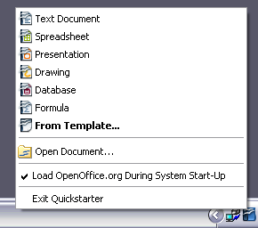
Figure 1: Quickstarter pop-up menu

Disabling the Quickstarter
To close the Quickstarter, right-click on the icon in the system tray, and then click Exit Quickstarter on the pop-up menu. The next time the computer is restarted, the Quickstarter will be loaded again.
To prevent OpenOffice.org from loading during system startup, deselect the Load OpenOffice.org during system start-up item on the pop-up menu. You might want to do this if your computer has insufficient memory, for example.

Reactivating the Quickstarter
If the Quickstarter has been disabled, you can reactivate it by selecting the Load OpenOffice.org during system start-up checkbox in Tools > Options > OpenOffice.org > Memory.

Using the Quickstarter in Linux
Some installations of OpenOffice.org under Linux have a Quickstarter that looks and acts like the one described above for Windows (the checkbox on the Memory page is labeled Enable systray quickstarter).

Preloading OOo under Linux/KDE
In Linux/KDE, you can use KDocker to have OOo loaded and ready for use at startup. KDocker is not part of OOo; it is a generic “systray app docker” that is helpful if you open OOo often.

Starting from the command line
You may want to start OOo from the command line (using the keyboard instead of the mouse). By using the command line, you have more control over what happens when OOo is started. For example, using the command line, you can tell Writer to load a document and print it immediately, or to start without showing the splash screen.
Note | Most users will never need to do this.
There is more than one way to start OOo from the command line, depending on whether you have installed a customized version or the standard download from the OOo website.
If you installed using the download on the OOo website, you can start Writer by typing at the command line:
soffice -writer
or
swriter
Writer will start and create a new document. Likewise, you can start other OOo components from the command line:
Type of document | Component | Command-line option
Text | Writer | -writer
Spreadsheet | Calc | -calc
Drawing | Draw | -draw
Presentation | Impress | -impress
Formula | Math | -math
Database | Base | -base
Web page | Writer | -web
To see a list of options you can use when starting Writer at the command line, type:
soffice -?
Below is a list of some of the more popular options.
Option | Description
-help | Get a complete list of options.
-nologo | Do not show the startup screen.
-show <odp-file> | Start presentation immediately.
-view <documents ...> | Open documents in viewer (read-only) mode.
-minimized | Start OOo minimized.
-norestore | Suppress restart/restore after fatal errors.
-invisible | No startup screen, no default document, and no UI. This is useful for third-party applications that use functionality provided by OOo.
If you have a customized version of OOo (such as the one provided by Linux Mandrake or Gentoo), you can start Writer by typing at the command line: oowriter
Although the command syntax differs, the effect is identical: it starts OOo with an empty Writer document.

Parts of the main window
The main window is similar in each component of OOo, although some details vary. See the chapters in this book about Writer, Calc, Draw, and Impress for descriptions of those details.
Common features include the menu bar, the standard toolbar, and the formatting toolbar at the top of the window and the status bar at the bottom.

Menu bar
The Menu bar is located across the top of the OOo window, just below the Title bar. When you choose one of the menus listed below, a submenu drops down to show commands.
- File contains commands that apply to the entire document such as Open, Save, and Export as PDF.
- Edit contains commands for editing the document such as Undo: xxx (where xxx is the command to undo) and Find & Replace. It also contains commands to cut, copy, and paste selected parts of your document.
- View contains commands for controlling the display of the document such as Zoom and Web Layout.
- Insert contains commands for inserting elements into your document such as Header, Footer, and Picture.
- Format contains commands, such as Styles and Formatting and AutoCorrect, for formatting the layout of your document.
- Table shows all commands to insert and edit a table in a text document.
- Tools contains functions such as Spelling and Grammar, Customize, and Options.
- Window contains commands for the display window.
- Help contains links to the OpenOffice.org Help file, What’s This?, and information about the program. See “How to get help“ on page 9.

Toolbars
OOo has several types of toolbars: docked, floating, and tear-off. Docked toolbars can be moved to different locations or made to float, and floating toolbars can be docked.
The top docked toolbar (default position) is called the Standard toolbar. The Standard toolbar is consistent across the OpenOffice.org applications.
The second toolbar across the top (default location) is the Formatting toolbar. It is a context-sensitive bar that shows the relevant tools in response to the cursor’s current position or selection. For example, when the cursor is on a graphic, the Formatting bar provides tools for formatting graphics; when the cursor is in text, the tools are for formatting text.

Displaying or hiding toolbars
To display or hide toolbars, choose View > Toolbars, then click on the name of a toolbar in the list. An active toolbar shows a checkmark beside its name. Tear-off toolbars are not listed in the View menu.

Submenus and tear-off toolbars
Toolbar icons with a small triangle to the right will display submenus, tear-off toolbars, and other ways of selecting things, depending on the icon.
Figure 2 shows a tear-off toolbar from the Drawing toolbar.
The tear-off toolbars can be floating or docked along an edge of the screen or in one of the existing toolbar areas. To move a floating tear-off toolbar, drag it by the title bar. See “Moving toolbars” below.
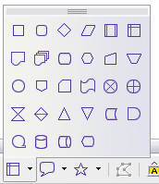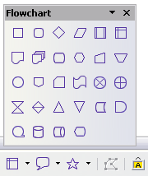

Figure 2: Example of a tear-off toolbar
Click here and drag
Toolbar tears off and floats

Moving toolbars
To move a docked toolbar, place the mouse pointer over the toolbar handle, hold down the left mouse button, drag the toolbar to the new location, and then release the mouse button (Figure 3).
To move a floating toolbar, click on its title bar and drag it to a new location (Figure 4).
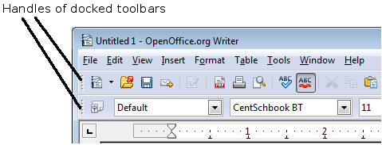
Figure 3: Moving a docked toolbar
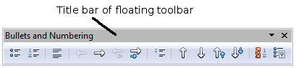
Figure 4: Moving a floating toolbar

Floating toolbars
OOo includes several additional context-sensitive toolbars, whose defaults appear as floating toolbars in response to the cursor’s current position or selection. For example, when the cursor is in a table, a floating Table toolbar appears, and when the cursor is in a numbered or bullet list, the Bullets and Numbering toolbar appears. You can dock these toolbars to the top, bottom, or side of the window, if you wish (see “Moving toolbars” above).

Docking/floating windows and toolbars
Toolbars and some windows, such as the Navigator and the Styles and Formatting window, are dockable. You can move, resize, or dock them to an edge.
To dock a window or toolbar, do one of the following:
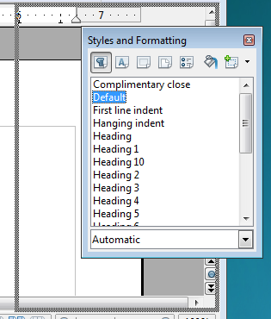
Figure 5: Docking a window
- Click on the title bar of the floating window and drag it to the side until you see the outline of a box appear in the main window, then release the window. This method depends on your system’s window manager settings, so it may not work for you.
- Hold down the Control key and double-click on the frame of the floating window (or in a vacant area near the icons at the top) to dock it in its last position. If that does not work, try double-clicking without using the Control key.
To undock a window, hold down the Control key and double-click on the frame (or a vacant area near the icons at the top) of the docked window.

Customizing toolbars
You can customize toolbars in several ways, including choosing which icons are visible and locking the position of a docked toolbar. You can also add icons and create new toolbars, as described in Chapter 14.
To access a toolbar’s customization options, use the down-arrow at the end of the toolbar or on its title bar (see Figure 6).
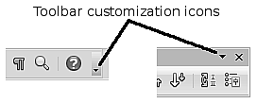Figure 6: Customizing toolbars
To show or hide icons defined for the selected toolbar, choose Visible Buttons from the drop-down menu. Visible icons have a checkmark next to them. Click on icons to select or deselect them.

Right-click (context) menus
You can quickly access many menu functions by right-clicking on a paragraph, graphics, or other object. A context menu will pop up. Often the context menu is the fastest and an easier way to reach a function. If you are not sure where in the menus or toolbars a function is located, you can often find it by right-clicking.

Status bar
The status bar is located at the bottom of the workspace. It provides information about the document and convenient ways to quickly change some features. It is similar in Writer, Calc, Impress, and Draw, although each component includes some component-specific items.
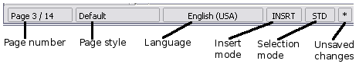Figure 7: Left end of status bar in Writer
Figure 8: Right end of status bar in Writer
Common status bar items are described below.
Page, sheet, or slide number
Shows the current page, sheet, or slide number and the total number of pages, sheets, or slides in the document. Double-click on this field to open the Navigator. Other uses of this field depend on the component.
Page style or slide design
Shows the current page style or slide design. To edit the current page style or slide design, double-click on this field.
Unsaved changes
An asterisk (*) appears here if changes to the document have not been saved.
Digital signature
If the document has been digitally signed, an icon shows here. You can double-click the icon to view the certificate.
Object information
Displays information relevant to the cursor’s position or the selected element of the document. Double-clicking in this area usually opens a relevant dialog.
Zoom slider and percent
To change the view magnification, drag the Zoom slider, or click on the + and – signs, or right-click on the zoom level percent to pop up a list of magnification values from which to choose.
Double-clicking on the zoom level percent opens the Zoom & View Layout dialog.

What are all these things called?
The terms used in OpenOffice.org for most parts of the user interface (the parts of the program you see and use, in contrast to the behind-the-scenes code that actually makes it work) are the same as for most other programs.
A dialog is a special type of window. Its purpose is to inform you of something, or request input from you, or both. It provides controls for you to use to specify how to carry out an action. The technical names for common controls are shown in Figure 9; not shown is the list box (from which you select an item). In most cases we do not use the technical terms in this book, but it is useful to know them because the Help and other sources of information often use them.
In most cases, as long as the dialog is open, your work is limited to the dialog. After you make changes, if any, close the dialog (usually, clicking OK or another button saves your changes and closes the dialog). Then you can again work with your document.
Some dialogs can be left open as you work, so you can switch back and forth between the dialog and your document. An example of this type is the Find & Replace dialog.
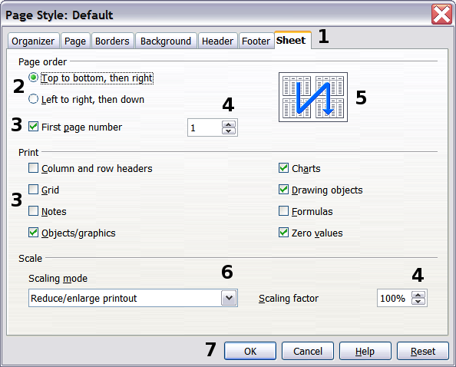
Figure 9: Dialog showing common controls:
1=Tabbed page (not strictly speaking a control)
2=Radio buttons (only one can be selected at a time)
3=Checkbox (more than one can be selected at a time)
4=Spin box (click the up and down arrows to change the number shown in the text box next to it, or type in the text box)
5=Thumbnail or preview
6=Drop-down list from which to select an item
7=Push buttons

Starting a new document
You can create a new, blank document in OOo in several ways.
When OOo is open but no document is open (for example if you close all the open documents but leave the program running), a Welcome screen is shown. Click one of the icons to open a new document of that type, or click the Templates icon to start a new document using a template.
You can also start a new document in one of the following ways. If a document is already open in OOo, the new document opens in a new window.
- Use File > New and choose the type of document.
- Use the arrow next to the New button on the main toolbar. From the drop-down menu, select the type of document to be created.
- Press Control+N on the keyboard.
- Use File > Wizards for some special types of documents.

Opening an existing document
When no document is open, the Welcome screen provides an icon for opening an existing document.
You can also open an existing document in one of the following ways.
- Click File > Open
- Click the Open button on the main toolbar.
- Press Control+O on the keyboard.
In each case, the Open dialog appears. Select the file you want, and then click Open. If a document is already open in OOo, the second document opens in a new window.
In the Open dialog, you can reduce the list of files by selecting the type of file you are looking for. For example, if you choose Text documents as the file type, you will only see documents Writer can open (including .odt, .doc, .txt); if you choose Spreadsheets, you will see .ods, .xsl, and other files that Calc opens.
You can also open an existing document that is in an OpenDocument format by double-clicking on the file’s icon on the desktop or in a file manager such as Windows Explorer.
If you have associated Microsoft Office file formats with OOo, you can also open these files by double-clicking on them.
Note | Under Microsoft Windows you can use either the OOo Open and Save As dialogs or the ones provided by Microsoft Windows. See “Using the Open and Save As dialogs” on page 24.

Saving documents
To save a new document, do one of the following:
- Press Control+S.
- Choose File > Save from the menu bar.
- Click the Save button on the main toolbar.
When the Save As dialog appears, enter the file name, verify the file type (if applicable), and click Save.
To save an open document with the current file name, choose File > Save. This will overwrite the last saved state of the file.

Password protection
To protect an entire document from being viewable without a password, use the option on the Save As dialog to enter a password. This option is only available for files saved in OpenDocument formats or the older OpenOffice.org 1.x formats.
- On the Save As dialog, select the Save with password option, and then click Save. You will receive a prompt (Figure 10).
- Type the same password in both fields, and then click OK. If the passwords match, the document is saved password protected. If the passwords do not match, you receive the prompt to enter the password again.
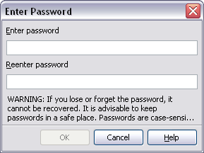Figure 10: Entering a password for a document
OOo uses a very strong encryption mechanism that makes it almost impossible to recover the contents of a document in case you lose the password.

Saving a document automatically
You can choose to have OpenOffice.org save files for you automatically. Automatic saving, like manual saving, overwrites the last saved state of the file. To set up automatic file saving:
- Choose Tools > Options... > Load/Save > General.
- Mark Save AutoRecovery information every, and set the time interval.

Renaming and deleting files
You can rename or delete files within the OOo dialogs, just as you can in your usual file manager. However, you cannot copy or paste files within the dialogs.

Using the Open and Save As dialogs
You can choose whether to use the OpenOffice.org Open and Save As dialogs or the ones provided by your operating system.
To view or change which type of dialog OpenOffice.org uses:
- Choose Tools > Options > OpenOffice.org > General.
- Select the Use OpenOffice.org dialogs option.
This section discusses the OpenOffice.org Open and Save As dialogs. Figure 11 shows the Save As dialog; the Open dialog is similar.
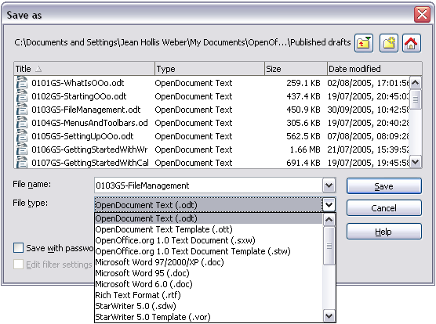Figure 11: The OpenOffice.org Save As dialog
The three buttons in the top right of the OOo Open and Save As dialogs are, from left to right:
- Go Up One Level in the folder (directory) hierarchy. Click and hold this button for a second to drop down a list of higher level folders; to go to one of the folders on the list, move the mouse pointer over its name and release the mouse button.
- Create New Folder.
- Default Directory.
For OOo documents that have been saved with more than one version, use the Version drop-down to select which version you wish to open in read-only mode. For Microsoft Office documents, only the current version can be opened.
Use the File type field to specify the type of file to be opened or the format of the file to be saved.
The Read-only option on the Open dialog opens the file for reading and printing only. Consequently, most of the toolbars disappear, and most menu options are disabled. An Edit File button is displayed on the Standard toolbar to open the file for editing.
You can open files from the Web by typing a URL in the File name field on the Open dialog.

Using the Navigator
The Navigator lists objects contained in a document, collected into categories. For example, in Writer it shows Headings, Tables, Text frames, Comments, Graphics, Bookmarks, and other items, as shown in Figure 12. In Calc it shows Sheets, Range Names, Database Ranges, Graphics, Drawing Objects, and other items. In Impress and Draw it shows Slides, Pictures, and other items.
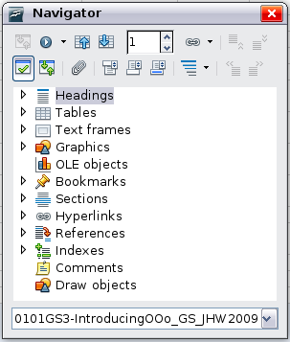
Figure 12: The Navigator
To open the Navigator, click its icon on the Standard toolbar, or press F5, or choose View > Navigator on the menu bar.
You can dock the Navigator to either side of the main OOo window or leave it floating (see “Docking/floating windows and toolbars“ on page 17).
Click the marker (+ or arrow) by any of the categories to display the list of objects in that category.
To hide the list of categories and show only the toolbars at the top, click the List Box On/Off icon . Click this icon again to show the list box.
The Navigator provides several convenient ways to move around a document and find items in it:
- When a category is showing the list of objects in it, double-click on an object to jump directly to that object’s location in the document.
Objects are much easier to find if you have given them names when creating them, instead of keeping OOo’s default graphics1, graphics2, Table1, Table2, and so on—which may not correspond to the position of the object in the document.
If you only want to see the content in a certain category, highlight the category and click the Content View icon . Until you click the icon again, only the objects of that category will be displayed.
- Click the Navigation icon (second icon from the left at the top of the Navigator) to display the Navigation toolbar (Figure 13). Here you can pick one of the categories and use the Previous and Next icons to move from one item to the next. This is particularly helpful for finding items like bookmarks and indexes, which can be difficult to see.
The names of the icons (shown in the tooltips) change to match the selected category; for example, Next Graphic or Next Bookmark.
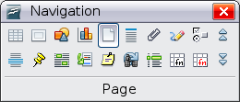
Figure 13: Navigation toolbar
- To jump to a specific page in the document, type its page number in the box at the top of the Navigator.
A bit of experimentation with the other icons will demonstrate their functions. Some component-specific uses are described in the chapters on Writer and the other components.

Undoing and redoing changes
To undo the most recent change, press Control+Z, or click the Undo icon on the Standard toolbar, or choose Edit > Undo from the menu bar.
The Edit menu shows the latest change that can be undone (see Figure 14 for an example from Writer).
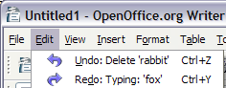
Figure 14: Edit > Undo last action
Click the small triangle to the right of the Undo icon to get a list of all the changes that can be undone (Figure 15). You can select multiple changes and undo them at the same time.
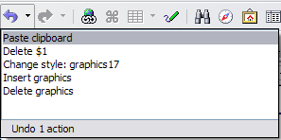
Figure 15: List of actions that can be undone
After changes have been undone, Redo becomes active. To redo a change, select Edit > Redo, or press Control+Y or click on the Redo icon . As with Undo, click on the triangle to the right of the arrow to get a list of the changes that can be reapplied.
To modify the number of changes OpenOffice.org remembers, choose Tools > Options > OpenOffice.org > Memory and in the Undo section change Number of steps. Be aware that asking OOo to remember more changes consumes more computer memory.

Closing a document
To close a document, choose File > Close.
You can also close a document by clicking on the Close icon on the document window. This button looks like the red X shown in Figure 16.
Figure 16. Close icons
If more than one OOo window is open, each window looks like the sample shown on the left in Figure 16. Closing this window leaves the other OOo windows open.
If only one OOo window is open, it looks like the sample shown on the right in Figure 16. Notice the small black X below the large red X. Clicking the small X closes the document but leaves OOo open. Clicking the large red X closes OOo completely.
If the document has not been saved since the last change, a message box is displayed. Choose whether to save or discard your changes.
- Save: The document is saved and then closed.
- Discard: The document is closed, and all modifications since the last save are lost.
- Cancel: Nothing happens, and you return to the document.
Caution   | Not saving your document could result in the loss of recently made changes, or worse still, your entire file.

Closing OpenOffice.org
To close OOo completely, choose File > Exit, or close the last open document as described in “Closing a document” above.
If all the documents have been saved, OOo closes immediately. If any documents have been modified but not saved, a warning message appears. Follow the procedure in “Closing a document” to save or discard your changes.

