
Lotus Symphony 3.0.1 / Apache OpenOffice 3.4
Code Merge UX Assessment

Print and Print Preview

Kevin Grignon
Version 1.0
2012 06 01

1.0 – Executive Summary

About the Assessment

In support of the Lotus Symphony 3.0.1 (LS) and Apache OpenOffice 3.4 (AOO) code merge activity, the Apache OpenOffice UX team has prepared the following user experience merge assessment. The outcome of the assessment is an understanding of which aspects of the print preview user experience should be migrated or merged from each offering into the new code base.

The following heuristics were considered in assessing the print and print preview feature under merge consideration.

- usability principles
- interaction principles
- promotes user adoption
- strategic usage goals
- AOO branding initiatives

UX Recommendations

Through an assessment of the user experience strengths, weaknesses, and opportunities for improvement of the print and print preview feature within each of the current implementations (LS and AOO), UX recommends the follow action:

- AOO 4.0 code base should adopt elements from both the Lotus Symphony and Apache OpenOffice print and print preview user experience design

Each offering demonstrated strengths and weaknesses that should be considered in migrating and merging the user experience for this feature.

- In merging the Lotus Symphony and Apache OpenOffice print and print preview user experience into the AOO 4.0 code base we should be mindful to address the following merge considerations and opportunities for improvement.

  - A24 - strengthen the information design and affordance of the Close print preview mode
  - A30 - emulate UI pattern of known, predictable and familiar print dialog to allow users to leverage their existing OS print dialog knowledge
  - A33 - Adopt AOO print options dialog, and ensure key attributes from LS are included in merge interaction design
  - A48 - adopt the LS information architecture and place print range commands in File main menu, proximate to other print commands
  - A51 (duplicate of A01, A06, A11, A36, A43) - adopt LS approach and cluster all print-related commands, including print, print preview and print ranges (where applicable) commands in File main menu
  - A52 (duplicate of A02, A07, A12, A37, A44) - provide menu icons for each print command to reinforce association with associated print-oriented contextual toolbars
  - A54 (duplicate of A39, A46) - adopt AOO approach to make the high frequency, broadly accepted and ecological responsible print option, print to .PDF, available in default toolbar
  - A55 (duplicate of A40, A47) - to promote migration and make the preview command label more explicit and contextual to a print action, re-name the preview from "Page Preview" to "Print Preview"
  - A56 (duplicate of A14) - support print preview in presentation editor, provide consistent experience with other editors
  - A57 (duplicate of A04, A09, A15) - make print preview command available in main toolbar
  - A58 - ensure zoom icon is consistent with other editors, replace paper and magnifying glass with magnifying glass
  - A79 (duplicate of A17, A61) - have print preview enter a separate print preview mode to focus tasks
  - A80 (duplicate of A18, A62) - only provide print-oriented context toolbar for key commands in print preview mode
  - A81 (duplicate of A19, A63) - provide main menu that is contextual to print preview mode
  - A82 (duplicate of A03, A08, A13, A20, A64) - provide standard print accelerator (Ctrl+P) for primary print command
  - A83 (duplicate of A21, A65) - adopt LS zoom toolbar design and behaviour
  - A84 (duplicate of A22, A66) - adopt LS page presentation options toolbar design and behaviour, ensure control evokes an interactive drop-down, versus modal dialog
  - A85 (duplicate of A23, A67) - optimize the default print preview zoom to leverage the available workspace - match the real world as much as possible
  - A86 (duplicate of A68) - adopt AOO command label for close print preview mode - Close Preview
  - A87 (duplicate of A69) - remove full screen mode,
  - A88 (duplicate of A70) - if full screen mode retained, improve the command label to close full screen
  - A89 (duplicate of A71) - if full screen mode retained, move to command to the zoom and presentation toolbar cluster, remove from print toolbar cluster
  - A90 (duplicate of A72) - ensure all editors have a consistent printing UI for common items (navigation, format page, zoom, print, close preview)
  - A91 (duplicate of A73) - if separate print preview still includes file and print toolbars, seek ways to unify the presentation and behaviour of print commands, including icon consistency and tool tip consistency
  - A92 - adopt LS available actions design approach and provide a print command in the page preview toolbar
  - A93 - adopt LS information design and rename page preview to print preview
  - A94 - provide ability to scale spreadsheet content to preview, using toolbar slider
  - A95 - provide a label for the spreadsheet content scaling control differentiate it from the document zooming command in footer
  - A96 - adopt AOO approach to provide access to page formatting options
  - A97 - adopt AOO approach to make interactive margins available

In addition, the assessment of each offering identified a number of opportunities for improvement to consider while performing the code merge. See Medium and Low priority issues in the following analysis.

For a summary of all recommendations (High, Medium and Low), see the action item summary at end of document.

Next Steps

To ensure that the assessment has an impact on the design direction of the feature merge moving forward, UX recommends the following actions:

- UX and Development review the recommendations
- UX and Development work together to promote design considerations into plan and address outstanding issues in the merged code UX
- UX and Development work together to promote the merged user experience within the AOO community
- UX and Development to work together to specify the detailed GUI design and user experience for merged print and print preview implementation
- Continue to assess high risk UX migration and merge candidates. See UX migration and merge worksheets for priorities.

2.0 - About this Assessment

In support of the Lotus Symphony 3.0.1 (LS) and Apache OpenOffice 3.4 (AOO) code merge activity, the Apache OpenOffice UX team has prepared the following user experience merge assessment. This assessment focuses on understanding the user experience strengths, weaknesses, and opportunities for improvement for the print and print preview features under merge consideration, within each of the current implementations. The intent of this assessment is to determine which aspects of the user experience should be maintained in the code base moving forward. The output of this assessment is a series of actionable recommendations to assist in making informed user experience design decisions in support of the code merge. The outcome of the assessment is an understanding of which aspects of the user experience should be migrated or merged from each offering into the new code base.

It should be stated that delivering the best possible user experience is always UX's key goal, however, to make such design decisions requires rich insight into the intended audience and goals. We need to be clear, as a design and development team, as to which audience we are designing for, what is their context of use, and how do such user goals and expectations relate to our broader business objectives? Developing such an understanding requires effort, and at the time of this assessment, such data was not fully available. In the interim, we have used the following heuristics to assess the print and print preview under merge consideration.

- usability principles
  - visibility of system status
  - visibility of available objects, action and options
  - match between system and real world
  - consistency and standards
  - navigation
  - flexibility and efficiency of use
  - structure of information
  - accessibility
  - aesthetic and minimalist design
  - error handling
  - help and documentation
- interaction principles
  - orientation
  - affordance
  - association
  - feedback
  - progressive disclosure and enablement
- promotes user adoption
  - realizes basic expectations
    - core office productivity tooling use cases
    - first 20 minutes
  - existing AOO users
    - transfer existing knowledge form previous versions
  - migration form other tools
    - commoditization of office tools
  - new users
    - get "up and running" quickly
- strategic usage goals
  - realize basic enterprise expectations
    - core enterprise office productivity tooling use cases
  - collaboration
  - social
  - integration
- AOO branding initiatives

3.0 - About Print and Print Preview

Both LS and AOO currently provide print preview modes which allow users to get a sense of what their document will look like in the context of a printed page. surface common actions. Each offering places the editors into a psuedo print preview mode, where the toolbar commands are contextual to the print mode. While the basic print and print preview modes are similar between the offerings, other aspects of the user experience are slightly different. Differences include toolbar layouts, print preview and print options UI design.

See analysis for more information.

4.0 - Analysis

Lotus Symphony 3.0.1 – Document Editor

File > [ICON] Print Preview
File > [ICON] Print… Ctrl+P

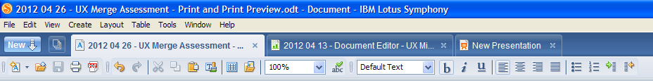
- toolbar print command part of File toolbar cluster

Emulate
- print and print preview commands available via main menu
- print and print preview menu command icons help reinforce association to print command in toolbar
- print command available via file cluster toolbar
- print command has assigned the standard print accelerator (Ctrl+P)

Avoid
- print preview command is not available by default in file toolbar cluster
- no way to customize toolbar content (file category) via context menu or preference dialog

Opportunity
- ensure that users can customize toolbar command content
- make print preview available in main toolbar

Actionable Design Considerations and Recommendations
High Priority
A01 - adopt LS approach and cluster all print-related commands, including print, print preview and print ranges (where applicable) commands in File main menu
A02 - provide menu icons for each print command to reinforce association with associated print-oriented contextual toolbars
A03 - provide standard print accelerator (Ctrl+P) for primary print command
A04 - adopt AOO approach to make print preview command available in main toolbar
Medium Priority
A05 - ensure that users can customize toolbar command content
Low Priority
- n/a

Lotus Symphony 3.0.1 – Spreadsheet Editor

File > Print Ranges > Define
Add
Remove
Edit...
File > [ICON] Print Preview
File > [ICON] Print...

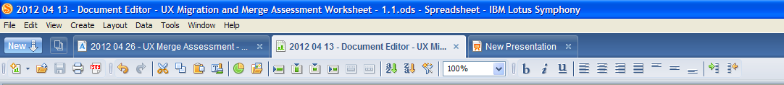
- toolbar print command part of File toolbar cluster

Emulate
- print range, print preview and print commands available via main menu
- print range command association with print preview and print commands is strong by clustering in same menu group
- print and print preview menu command icons help reinforce association to print command in toolbar
- print command available via file cluster toolbar
- print command has assigned the standard print accelerator (Ctrl+P)

Avoid
- print preview command is not available by default in file toolbar cluster
- no way to customize toolbar content (file category) via context menu or preference dialog

Opportunity
- ensure that users can customize toolbar command content
- make print preview available in main toolbar

Actionable Design Considerations and Recommendations
High Priority
A06 (duplicate of A01) - adopt LS approach and cluster all print-related commands, including print, print preview and print ranges (where applicable) commands in File main menu
A07 (duplicate of A02) - provide menu icons for each print command to reinforce association with associated print-oriented contextual toolbars
A08 (duplicate of A03) - provide standard print accelerator (Ctrl+P) for primary print command
A09 (duplicate of A04) - adopt AOO approach to make make print preview command available in main toolbar
Medium Priority
A10 (duplicate of A05) - ensure that users can customize toolbar command content
Low Priority
- n/a

Lotus Symphony 3.0.1 – Presentation Editor

File > [ICON] Print… Ctrl+P

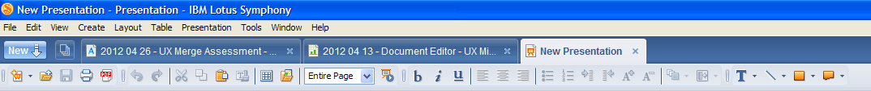
- toolbar print command part of File toolbar cluster

Emulate
- print commands available via main menu
- print menu command icon help reinforce association to print command in toolbar
- print command available via file cluster toolbar
- print command has assigned the standard print accelerator (Ctrl+P)

Avoid
- print preview command is not available via main menu
- print preview command is not available by default in file toolbar cluster
- no way to customize toolbar content (file category) via context menu or preference dialog

Opportunity
- support print preview
- ensure that users can customize toolbar command content
- make print preview available in main toolbar

Actionable Design Considerations and Recommendations
High Priority
A11 (duplicate of A01, A06) - adopt LS approach and cluster all print-related commands, including print, print preview and print ranges (where applicable) commands in File main menu
A12 (duplicate of A02, A07) - provide menu icons for each print command to reinforce association with associated print-oriented contextual toolbars
A13 (dupicate of A03, A08) - provide standard print accelerator (Ctrl+P) for primary print command
A14 - support print preview in presentation editor, provide consistent experience with other editors
A15 (duplicate of A04, 09) - adopt AOO approach to make make print preview command available in main toolbar
Medium Priority
A16 (duplicate of A05, A10) - ensure that users can customize toolbar command content
Low Priority
- n/a

Lotus Symphony 3.0.1 - Print Preview Mode

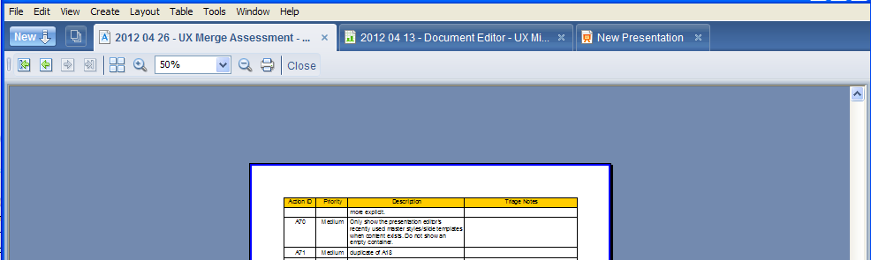
Emulate
- print preview enters a separate mode which helps focus user on tasks, only presenting actions contextual to print activity
- good clustering of page navigation toolbar commands
- print menu command icon help reinforce association to print command in toolbar
- print command available via file cluster toolbar
- print command has assigned the standard print accelerator (Ctrl+P)
- zoom in and zoom out, bookending the zoom drop down helps reinforce zoom commands

Avoid
- print preview mode is very similar to document editing mode, the contrast between the two modes is week and may confuse users, consider strengthening the orientation affordance of the interface
- file toolbar commands are confusing in this mode
- default document zoom does not optimize the available real-estate
- no way to customize print preview toolbar content (file category) via context menu or preference dialog
- place print command in separate cluster, have zoom commands in their own cluster
- Close command is ambiguous and does not reinforce the association between the print mode and how the user might return to the document editor, it's a navigation control as much as view command

Opportunity
- increase the contrast between document editing mode and print preview mode to reinforce the orientation of the user within the print preview mode
- optimize default zoom to leverage available workspace, to goal is to make a physical printout, so show the artifact as large as possible so the preview matches the real world output as much as possible
- do not include file toolbar commands (new, open and save) in print preview mode by default
- ensure that users can customize toolbar command content
- create print options task panes to support print options
- support keyboard accelerators for first and last page navigation
- support keyboard accelerators for zoom
- make page layout control and interactive drop-down versus a dialog
- strengthen association between zoom in and out commands with the zoom drop down menu
- place print command in it's own cluster
- emphasize close print preview mode, consider placing command at far left of toolbar, and include some affordances to reinforce vector and closing/return gesture

Actionable Design Considerations and Recommendations
High Priority
A17 - have print preview enter a separate print preview mode to focus tasks
A18 - only provide print-oriented context toolbar for key commands in print preview mode
A19 - provide main menu that is contextual to print preview mode
A20 (duplicate of A03, A08, A13) - provide standard print accelerator (Ctrl+P) for primary print command
A21 - adopt LS zoom toolbar design and behaviour
A22 - adopt LS page presentation options toolbar design and behaviour, ensure control evokes an interactive drop-down, versus modal dialog
A23 - optimize the default print preview zoom to leverage the available workspace - match the real world as much as possible
A24 - strengthen the information design and affordance of the Close print preview mode
Medium Priority
A25 - cluster zoom toolbar commands in zoom category to strengthen assocation between zoom in/out and zoom drop down control
A26 - explore the creation of a print preview options task pane to support the print preview mode
A27 (duplicate of A05, A10, A16) - ensure that users can customize toolbar command content
Low Priority
A28 - provide keyboard accelerators for page navigation in print preview
A29 - provide keyboard accelerators for zoom levels in print preview mode

Lotus Symphony 3.0.1 - Print Dialog

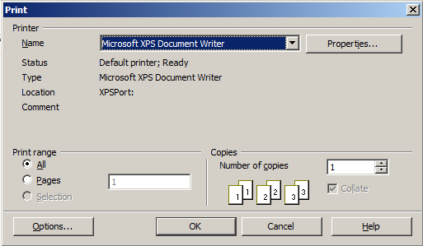
Emulate
- standard, predictable and familiar print dialog will allow users to leverage their existing print dialog knowledge

Avoid
- printer details outside name are distracting
- print range and copies content UI is too dense

Opportunity
- make printer details, except name drop down, available on demand
- print range and copies group boxes UI layout density should be reduced

Actionable Design Considerations and Recommendations
High Priority
A30 - emulate UI pattern of known, predictable and familiar print dialog to allow users to leverage their existing OS print dialog knowledge
Medium Priority
A31 - apply progressive disclosure pattern to printer details to make available on demand
Low Priority
A32 - reduce density of UI layout for print range, and copies group box content

Lotus Symphony 3.0.1 - Print Options Dialog
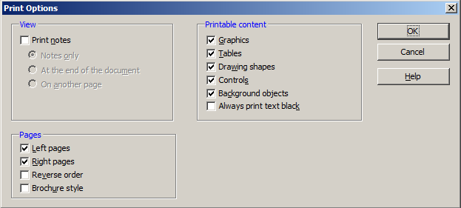

Emulate
- single view for all print options

Avoid
- user must evoke a secondary command, Options..., to view this options
- options arrays are long, and require the user to read each option

Opportunity
- make printer details, except name drop down, available on demand
- print range and copies group boxes UI layout density should be reduced
- consider interaction command buttons with icons for some of the print options

Actionable Design Considerations and Recommendations
High Priority
A33 - Adopt AOO print options dialog, and ensure key attributes from LS are included in merge interaction design
Medium Priority
A34 (duplicate of A31) - apply progressive disclosure pattern to printer details to make available on demand
Low Priority
A35 - to provide more visual illustrations of print options, explore interactive, visually compelling print options command buttons

Apache OpenOffice 3.4 – Document Editor

File > [ICON] Page Preview
File > [ICON] Print… Ctrl+P
File > [ICON] Printer Settings...

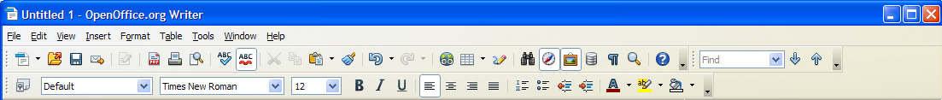
- part of Standard toolbar command cluster

Emulate
- print, print preview, and printer settings commands available via main menu
- print, print preview menu command icons help reinforce association to print command in toolbar
- print commands available via standard toolbar category
- print command has assigned the standard print accelerator (Ctrl+P)
- high frequency print option, print to .pdf is visible in default standard toolbar
- toolbar drop down provides easy access to toolbar content customization

Avoid
- toolbar options drop down visual style/affordance need not be so emphasized, only competes for attention when scanning toolbar
- page preview command label is not standard, and may confuse users

Opportunity
- de-emphazise the styling of toolbar option drop-down, perhaps something similar and balanced with the 5 vertical dotted grab handles.
- make print as .pdf available in main toolbar
- to promote migration and make the preview command label more contextual to a print action, re-name the preview from "Page Preview" to "Print Preview"

Actionable Design Considerations and Recommendations
High Priority
A36 (duplicate of A01, A06, A11) - adopt LS approach and cluster all print-related commands, including print, print preview and print ranges (where applicable)commands in File main menu
A37 (duplicate of A02, A07, A12) - provide menu icons for each print command to reinforce association with associated print-oriented contextual toolbars
A38 (dupicate of A03, A08, A13) - provide standard print accelerator (Ctrl+P) for primary print command
A39 - adopt AOO approach to make the high frequency, broadly accepted and ecological responsible print option, print to .PDF, available in default toolbar
A40 - to promote migration and make the preview command label more explicit and contextual to a print action, re-name the preview from "Page Preview" to "Print Preview"
Medium Priority
A41 (duplicate of A05, A10, A16) - ensure that users can customize toolbar command content
Low Priority
A42 - de-emphazise the styling of toolbar option drop-down, perhaps something similar and balanced with the 5 vertical dotted grab handles.

Apache OpenOffice 3.4 - Spreadsheet Editor

File > [ICON] Page Preview
File > [ICON] Print… Ctrl+P
File > [ICON] Printer Settings...
Format> Print Ranges > [ICON] Define
[ICON] Add
[ICON] Remove
[ICON] Edit...

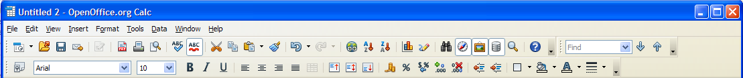
- part of Standard toolbar command cluster

Emulate
- print, page preview, and printer settings commands available via main menu
- print, page preview menu command icons help reinforce association to print command in toolbar
- print commands available via standard toolbar category
- print command has assigned the standard print accelerator (Ctrl+P)
- high frequency print option, print to .pdf is visible in default standard toolbar
- toolbar drop down provides easy access to toolbar content customization

Avoid
- toolbar options drop down visual style/affordance need not be so emphasized, only competes for attention when scanning toolbar
- print ranges command within the format menu is not discoverable
- page preview command label is not standard, and may confuse users

Opportunity
- de-emphazise the styling of toolbar option drop-down, perhaps something similar and balanced with the 5 vertical dotted grab handles.
- make print as .pdf available in main toolbar
- make print range commands available via the file menu proximate to other print commands
- to promote migration and make the preview command label more contextual to a print action, re-name the preview from "Page Preview" to "Print Preview"

Actionable Design Considerations and Recommendations
High Priority
A43 (duplicate of A01, A06, A11, A36) - adopt LS approach and cluster all print-related commands, including print, print preview and print ranges (where applicable) commands in File main menu
A44 (duplicate of A02, A07, A12, A37) - provide menu icons for each print command to reinforce association with associated print-oriented contextual toolbars
A45 (dupicate of A03, A08, A13, A38) - provide standard print accelerator (Ctrl+P) for primary print command
A46 (duplicate of A39) - adopt AOO approach to make the high frequency, broadly accepted and ecological responsible print option, print to .PDF, available in default toolbar
A47 (duplicate of A40) - to promote migration and make the preview command label more explicit and contextual to a print action, re-name the preview from "Page Preview" to "Print Preview"
A48 - adopt the LS information architecture and place print range commands in File main menu, proximate to other print commands
Medium Priority
A49 (duplicate of A05, A10, A16, A41) - ensure that users can customize toolbar command content
Low Priority
A50 (duplicate of A42) - de-emphazise the styling of toolbar option drop-down, perhaps something similar and balanced with the 5 vertical dotted grab handles.

Apache OpenOffice 3.4 - Presentation Editor

File > [ICON] Print… Ctrl+P
File > [ICON] Printer Settings...

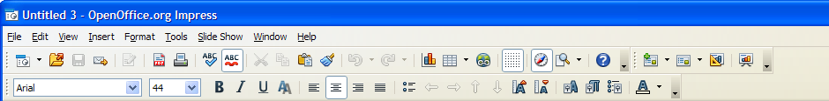
- part of Standard toolbar command cluster

Emulate
- print and printer settings commands available via main menu
- print menu command icon help reinforce association to print command in toolbar
- print commands available via standard toolbar category
- print command has assigned the standard print accelerator (Ctrl+P)
- high frequency print option, print to .pdf is visible in default standard toolbar
- toolbar drop down provides easy access to toolbar content customization

Avoid
- toolbar options drop down visual style/affordance need not be so emphasized, only competes for attention when scanning toolbar
- zoom icon uses the print preview icon and is inconsistent with zoom icon in other editors

Opportunity
- de-emphazise the styling of toolbar option drop-down, perhaps something similar and balanced with the 5 vertical dotted grab handles.
- make print as .pdf available in main toolbar
- ensure zoom icon is consistent with other editors, replace paper and magnifying glass with magnifying glass

Actionable Design Considerations and Recommendations
High Priority
A51 (duplicate of A01, A06, A11, A36, A43) - adopt LS approach and cluster all print-related commands, including print, print preview and print ranges (where applicable) commands in File main menu
A52 (duplicate of A02, A07, A12, A37, A44) - provide menu icons for each print command to reinforce association with associated print-oriented contextual toolbars
A53 (dupicate of A03, A08, A13, A38, A45) - provide standard print accelerator (Ctrl+P) for primary print command
A54 (duplicate of A39, A46) - adopt AOO approach to make the high frequency, broadly accepted and ecological responsible print option, print to .PDF, available in default toolbar
A55 (duplicate of A40, A47) - to promote migration and make the preview command label more explicit and contextual to a print action, re-name the preview from "Page Preview" to "Print Preview"
A56 (duplicate of A14) - support print preview in presentation editor, provide consistent experience with other editors
A57 (duplicate of A04, 09, A15) - make print preview command available in main toolbar
A58 - ensure zoom icon is consistent with other editors, replace paper and magnifying glass with magnifying glass
Medium Priority
A59 (duplicate of A05, A10, A16, A41, A58) - ensure that users can customize toolbar command content
Low Priority
A60 (duplicate of A42, A50) - de-emphazise the styling of toolbar option drop-down, perhaps something similar and balanced with the 5 vertical dotted grab handles.

Apache OpenOffice 3.4 - Print Preview - Writer

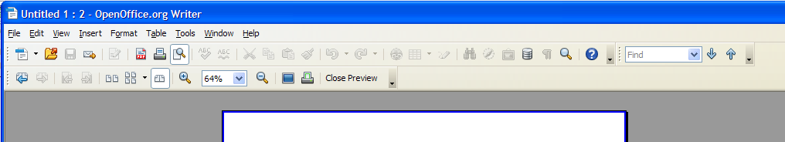
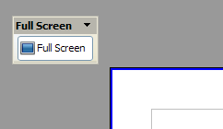
Emulate
- print preview enters a separate mode which helps focus user on tasks, only presenting contextual print toolbar
- good clustering of page navigation on print preview toolbar
- print menu command icon help reinforce association to print command in toolbar
- print command has assigned the standard print accelerator (Ctrl+P)
- provides access to page preview presentation options
- zoom in and zoom out, bookending the zoom drop down helps reinforce zoom commands
- drop-down zoom control offers fidelity
- offers ability to enter full screen mode
- print command available via standard toolbar, and page preview toolbar
- provide command to close preview, explicit text is helpful

Avoid
- print preview mode is very similar to document editing mode, the contrast between the two modes is week and may confuse users, consider strengthening the orientation affordance of the interface
- main menu commands and standard and find toolbar commands are confusing in this mode
- print contextual toolbar is inconsistent between doc and spreadsheet editor
- default document zoom does not optimize the available real-estate
- toolbar contains too many page preview display options and triggers
- exit full screen mode command is poorly labeled
- full screen mode offers no commands just display presentation
- full screen toolbar offers customization and locking controls, which is not necessary
- print document icon on print mode toolbar is different than the print displayed in the standard toolbar
- print in standard toolbar is labeled, Print file directly, then includes filename - this is too verbose
- place print command in separate cluster, have zoom commands in their own cluster

Opportunity
- increase the contrast between document editing mode and print preview mode to reinforce the orientation of the user within the print preview mode
- optimize default zoom to leverage available workspace, to goal is to make a physical printout, so show the artifact as large as possible so the preview matches the real world output as much as possible
- do not include file toolbar commands in print preview mode by default
- ensure that users can customize toolbar command content
- explore the creation of a print options task panes to support print options
- support keyboard accelerators for first and last page navigation
- support keyboard accelerators for zoom
- make page layout control and interactive drop-down versus a dialog
- place print command in it's own cluster
- emphasize close print preview mode, consider placing command at far left of toolbar, and include some affordances to reinforce vector and closing/return gesture
- ensure all editors have a consistent printing UI for common items
- navigation
- format page
- zoom
- full screen
- print
- close preview
- explore ways to simplify the page preview presentation options
- explore ways to optimize value of full screen, otherwise, consider removing
- a more explicit print mode will reduce the need for full screen preview and mitigate associated interaction design issues
- if we retain full screen, improve the command label to close full screen
- if we retain full screen command, move to zoom and presentation toolbar cluster, remove from print toolbar cluster
- unify the presentation and behaviour of the print commands
- make the print icons consistent
- reduce the verbose tooltip for "print file directly (file name)
- move print command to separate cluster

Actionable Design Considerations and Recommendations
High Priority
A61 (duplicate of A17) - have print preview enter a separate print preview mode to focus tasks
A62 (duplicate of A18) - only provide print-oriented context toolbar for key commands in print preview mode
A63 (duplicate of A19) - provide main menu that is contextual to print preview mode
A64 (duplicate of A03, A08, A13, A20) - provide standard print accelerator (Ctrl+P) for primary print command
A65 (duplicate of A21) - adopt LS zoom toolbar design and behaviour
A66 (duplicate of A22) - adopt LS page presentation options toolbar design and behaviour, ensure control evokes an interactive drop-down, versus modal dialog
A67 (duplicate of A23) - optimize the default print preview zoom to leverage the available workspace - match the real world as much as possible
A68 - adopt AOO command label for close print preview mode - Close Preview
A69 - remove full screen mode,
A70 - if full screen mode retained, improve the command label to close full screen
A71 - if full screen mode retained, move to command to the zoom and presentation toolbar cluster, remove from print toolbar cluster
A72 - ensure all editors have a consistent printing UI for common items (navigation, format page, zoom, print, close preview)
A73 - if separate print preview still includes file and print toolbars, seek ways to unify the presentation and behaviour of print commands, including icon consistency and tool tip consistency
Medium Priority
A74 (duplicate of A25) - cluster zoom toolbar commands in zoom category to strengthen assocation between zoom in/out and zoom drop down control
A75 (duplicate of A26) - explore the creation of a print preview options task pane to support the print preview mode
A76 (duplicate of A05, A10, A16, A27) - ensure that users can customize toolbar command content
Low Priority
A77 (duplicate of A28) - provide keyboard accelerators for page navigation in print preview
A78 (duplicate of A29) - provide accelerators for zoom levels in print preview mode

Apache OpenOffice 3.4 - Print Preview - Calc

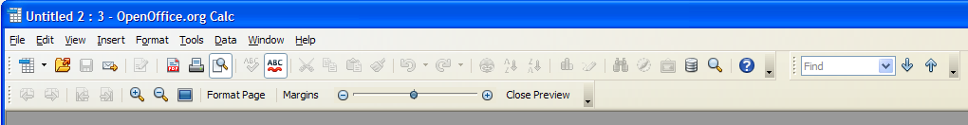
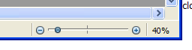
Emulate
- print preview enters a separate mode which helps focus user on tasks, only presenting contextual print toolbar
- good clustering of page navigation on print preview toolbar
- print menu command icon help reinforce association to print command in toolbar
- print command has assigned the standard print accelerator (Ctrl+P)
- provides access to page formating options
- zoom in and zoom out are clustered with full screen
- ability to make interactive margins available for editing
- offers ability to enter full screen mode
- offers the ability to scale print content from preview toolbar
- print command available via standard toolbar
- provide command to close preview, explicit text is helpful

Avoid
- print preview mode is very similar to document editing mode, the contrast between the two modes is week and may confuse users, consider strengthening the orientation affordance of the interface
- main menu commands and standard and find toolbar commands are confusing in this mode
- print contextual toolbar is inconsistent between doc and spreadsheet editor
- default document zoom does not optimize the available real-estate
- page preview toolbar items have poor command clustering
- exit full screen mode command is poorly labeled
- full screen mode offers no commands just display presentation
- full screen toolbar offers customization and locking controls, which is not necessary
- no print command on the page preview toolbar
- print in standard toolbar is labeled, Print file directly, then includes filename - this is too verbose
- have page formating, margin in their own cluster, have close in it's own cluster
- scale print content (in page preview toolbar) and page zoom (in application footer) are very similiar but produce different results
- information design makes it appear that "margins" is the content scaling control's parent command label, and that the slide has an impact on the margins

Opportunity
- increase the contrast between document editing mode and print preview mode to reinforce the orientation of the user within the print preview mode
- optimize default zoom to leverage available workspace, to goal is to make a physical printout, so show the artifact as large as possible so the preview matches the real world output as much as possible
- do not include file toolbar commands in print preview mode by default
- ensure that users can customize toolbar command content
- explore the creation of a print options task panes to support print options
- support keyboard accelerators for first and last page navigation
- support keyboard accelerators for zoom
- make page layout control and interactive drop-down versus a dialog
- emphasize close print preview mode, consider placing command at far left of toolbar, and include some affordances to reinforce vector and closing/return gesture
- ensure all editors have a consistent printing UI for common items
- navigation
- format page
- zoom
- full screen
- print
- close preview
- explore ways to optimize value of full screen, otherwise, consider removing
- a more explicit print mode will reduce the need for full screen preview and mitigate associated interaction design issues
- if we retain full screen, improve the command label to close full screen
- if we retain full screen command, move to zoom and presentation toolbar cluster, remove from print toolbar cluster
- provide a print command in the page preview toolbar
- rename page preview to print preview
- consider separating interactive page setup from print mode
- reduce the verbose tooltip for "print file directly (filename)
- make print tooltip on standard toolbar less verbose and more succinct
- move page commands to their own print preview toolbar cluster
- move close preview mode to it's own menu cluster
- provide a label for the context scaling control differentiate it from the document zooming command in footer

Actionable Design Considerations and Recommendations
High Priority
A79 (duplicate of A17, A61) - have print preview enter a separate print preview mode to focus tasks
A80 (duplicate of A18, A62) - only provide print-oriented context toolbar for key commands in print preview mode
A81 (duplicate of A19, A63) - provide main menu that is contextual to print preview mode
A82 (duplicate of A03, A08, A13, A20, A64) - provide standard print accelerator (Ctrl+P) for primary print command
A83 (duplicate of A21, A65) - adopt LS zoom toolbar design and behaviour
A84 (duplicate of A22, A66) - adopt LS page presentation options toolbar design and behaviour, ensure control evokes an interactive drop-down, versus modal dialog
A85 (duplicate of A23, A67) - optimize the default print preview zoom to leverage the available workspace - match the real world as much as possible
A86 (duplicate of A68) - adopt AOO command label for close print preview mode - Close Preview
A87 (duplicate of A69) - remove full screen mode,
A88 (duplicate of A70) - if full screen mode retained, improve the command label to close full screen
A89 (duplicate of A71) - if full screen mode retained, move to command to the zoom and presentation toolbar cluster, remove from print toolbar cluster
A90 (duplicate of A72) - ensure all editors have a consistent printing UI for common items (navigation, format page, zoom, print, close preview)
A91 (duplicate of A73) - if separate print preview still includes file and print toolbars, seek ways to unify the presentation and behaviour of print commands, including icon consistency and tool tip consistency
A92 - adopt LS available actions design approach and provide a print command in the page preview toolbar
A93 - adopt LS information design and rename page preview to print preview
A94 - provide ability to scale spreadsheet content to preview, using toolbar slider
A95 - provide a label for the spreadsheet content scaling control differentiate it from the document zooming command in footer
A96 - adopt AOO approach to provide access to page formatting options
A97 - adopt AOO approach to make interactive margins available
Medium Priority
A98 (duplicate of A25, A74) - cluster zoom toolbar commands in zoom category to strengthen association between zoom in/out and zoom drop down control
A99 (duplicate of A26, A75) - explore the creation of a print preview options task pane to support the print preview mode
A100 (duplicate of A05, A10, A16), A27, A76) - ensure that users can customize toolbar command content
A101 - explore the creation of an interactive page setup view with supporting task panes for key properties
A102 - reduce the verbose tooltip for "print file directly (file name),
A103 - make print tooltip on standard toolbar less verbose and more succinct
Low Priority
A104 (duplicate of A28, A77) - provide keyboard accelerators for page navigation in print preview
A105 (duplicate of A29, A78) - provide accelerators for zoom levels in print preview mode

Apache OpenOffice 3.4 - Print Dialog

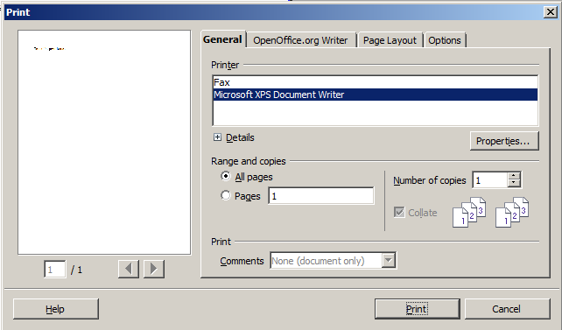
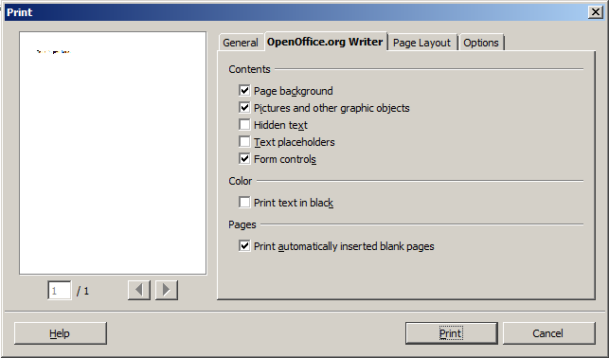

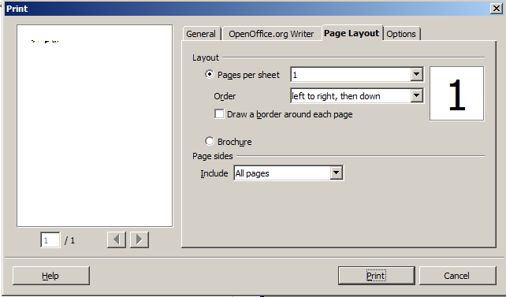
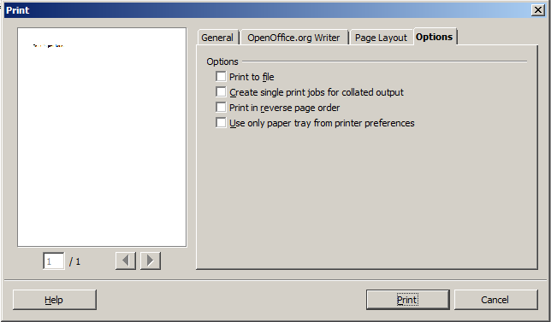
Emulate
- standard, predictable and familiar print dialog will allow users to leverage their existing print dialog knowledge
- show/hide print setting details is good, as this information is rarely accessed
- print preview
- ability to navigate pages
- common print dialog with editor contextual commands
- view offers access to help

Avoid
- print range, copies content, and print comment UI is too dense
- pages per sheet preview could include pages visual element in page, rather than number
- layout order commands could be clearer and require less reading if visualization previews provided

Opportunity
- make printer details, except name drop down, available on demand
- print range, copies and print comments UI layout density should be reduced
- layout order commands could be clearer and require less reading if visualization previews provided

Actionable Design Considerations and Recommendations
High Priority
A106 (duplicate of A33) - Adopt AOO print options dialog, and ensure key attributes from LS are included in merge interaction design
Medium Priority
A107 (duplicate of A26, A75, A99) - explore the creation of a print preview options task pane to support the print preview mode, consider eliminating print options modal view
A108 (duplicate of A31, A34) - apply progressive disclosure pattern to printer details to make available on demand
A109 - layout order commands could be clearer and require less reading if visualization previews provided
Low Priority
A110 (duplicate of A35) - to provide more visual illustrations of print options, explore interactive, visually compelling print options command buttons

References

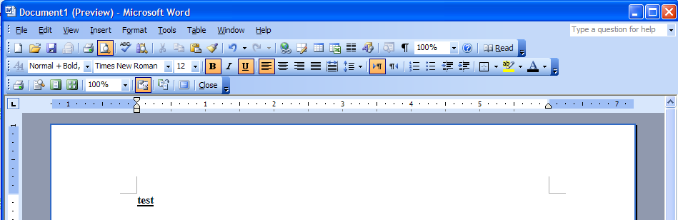
MS Office Print Preview

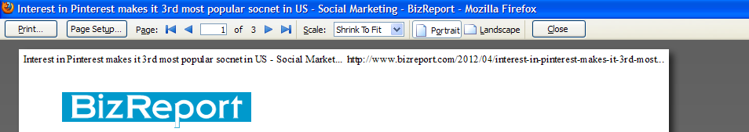
Firefox Print Preview

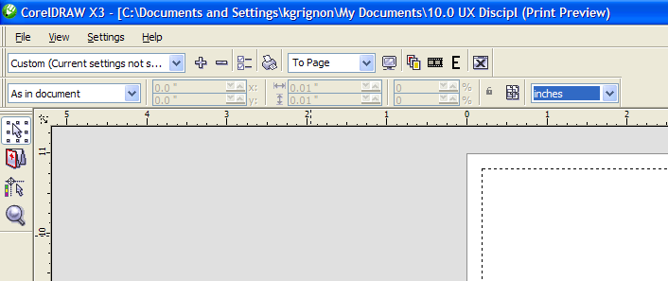
CorelDRAW Print Preview

4.0 – Action Item Summary

Action ID | Priority | Description | Triage Notes
A01 | High | adopt LS approach and cluster all print-related commands, including print, print preview and print ranges (where applicable) commands in File main menu
A02 | High | provide menu icons for each print command to reinforce association with associated print-oriented contextual toolbars
A03 | High | provide standard print accelerator (Ctrl+P) for primary print command
A04 | High | adopt AOO approach to make print preview command available in main toolbar
A05 | Medium | ensure that users can customize toolbar command content
A06 | High | duplicate of A01
A07 | High | duplicate of A02
A08 | High | duplicate of A03
A09 | High | duplicate of A04
A10 | Medium | duplicate of A05
A11 | High | duplicate of A01, A06
A12 | High | duplicate of A02, A07
A13 | High | duplicate of A03, A08
A14 | High | support print preview in presentation editor, provide consistent experience with other editors
A15 | High | duplicate of A04, 09
A16 | Medium | duplicate of A05, A10
A17 | High | have print preview enter a separate print preview mode to focus tasks
A18 | High | only provide print-oriented context toolbar for key commands in print preview mode
A19 | High | provide main menu that is contextual to print preview mode
A20 | High | duplicate of A03, A08, A13
A21 | High | adopt LS zoom toolbar design and behaviour
A22 | High | adopt LS page presentation options toolbar design and behaviour, ensure control evokes an interactive drop-down, versus modal dialog
A23 | High | optimize the default print preview zoom to leverage the available workspace - match the real world as much as possible
A24 | High | strengthen the information design and affordance of the Close print preview mode
A25 | Medium | cluster zoom toolbar commands in zoom category to strengthen assocation between zoom in/out and zoom drop down control
A26 | Medium | explore the creation of a print preview options task pane to support the print preview mode
A27 | Medium | duplicate of A05, A10, A16
A28 | Low | provide keyboard accelerators for page navigation in print preview
A29 | Low | provide keyboard accelerators for zoom levels in print preview mode
A30 | High | emulate UI pattern of known, predictable and familiar print dialog to allow users to leverage their existing OS print dialog knowledge
A31 | Medium | apply progressive disclosure pattern to printer details to make available on demand
A32 | Low | reduce density of UI layout for print range, and copies group box content
A33 | High | Adopt AOO print options dialog, and ensure key attributes from LS are included in merge interaction design
A34 | Medium | duplicate of A31
A35 | Low | to provide more visual illustrations of print options, explore interactive, visually compelling print options command buttons
A36 | High | duplicate of A01, A06, A11
A37 | High | duplicate of A02, A07, A12
A38 | High | duplicate of A03, A08, A13
A39 | High | adopt AOO approach to make the high frequency, broadly accepted and ecological responsible print option, print to .PDF, available in default toolbar
A40 | High | to promote migration and make the preview command label more explicit and contextual to a print action, re-name the preview from "Page Preview" to "Print Preview"
A41 | Medium | duplicate of A05, A10, A16
A42 | Low | de-emphazise the styling of toolbar option drop-down, perhaps something similar and balanced with the 5 vertical dotted grab handles.
A43 | High | duplicate of A01, A06, A11, A36
A44 | High | duplicate of A02, A07, A12, A37
A45 | High | duplicate of A03, A08, A13, A38)
A46 | High | duplicate of A39
A47 | High | duplicate of A40
A48 | High | adopt the LS information architecture and place print range commands in File main menu, proximate to other print commands
A49 | Medium | duplicate of A05, A10, A16, A41)
A50 | Low | duplicate of A42
A51 | High | duplicate of A01, A06, A11, A36, A43
A52 | High | duplicate of A02, A07, A12, A37, A44
A53 | High | duplicate of A03, A08, A13, A38, A45
A54 | High | duplicate of A39, A46
A55 | High | duplicate of A40, A47
A56 | High | duplicate of A14
A57 | High | duplicate of A04, A09, A15
A58 | High | ensure zoom icon is consistent with other editors, replace paper and magnifying glass with magnifying glass
A59 | Medium | duplicate of A05, A10, A16, A41
A60 | Low | duplicate of A42, A50
A61 | High | duplicate of A17
A62 | High | duplicate of A18
A63 | High | duplicate of A19
A64 | High | duplicate of A03, A08, A13, A20
A65 | High | duplicate of A21
A66 | High | duplicate of A22
A67 | High | duplicate of A23
A68 | High | adopt AOO command label for close print preview mode - Close Preview
A69 | High | remove full screen mode,
A70 | High | if full screen mode retained, improve the command label to close full screen
A71 | High | if full screen mode retained, move to command to the zoom and presentation toolbar cluster, remove from print toolbar cluster
A72 | High | ensure all editors have a consistent printing UI for common items (navigation, format page, zoom, print, close preview)
A73 | High | if separate print preview still includes file and print toolbars, seek ways to unify the presentation and behaviour of print commands, including icon consistency and tool tip consistency
A74 | Medium | duplicate of A25
A75 | Medium | duplicate of A26
A76 | Medium | duplicate of A05, A10, A16, A27
A77 | Low | duplicate of A28
A78 | Low | duplicate of A29
A79 | High | duplicate of A17, A61
A80 | High | duplicate of A18, A62
A81 | High | duplicate of A19, A63
A82 | High | duplicate of A03, A08, A13, A20, A64
A83 | High | duplicate of A21, A65
A84 | High | duplicate of A22, A66
A85 | High | duplicate of A23, A67
A86 | High | duplicate of A68
A87 | High | duplicate of A69
A88 | High | duplicate of A70
A89 | High | duplicate of A71
A90 | High | duplicate of A72
A91 | High | duplicate of A73
A92 | High | adopt LS available actions design approach and provide a print command in the page preview toolbar
A93 | High | adopt LS information design and rename page preview to print preview
A94 | High | provide ability to scale spreadsheet content to preview, using toolbar slider
A95 | High | provide a label for the spreadsheet content scaling control differentiate it from the document zooming command in footer
A96 | High | adopt AOO approach to provide access to page formatting options
A97 | High | adopt AOO approach to make interactive margins available
A98 | Medium | duplicate of A25, A74
A99 | Medium | duplicate of A26, A75
A100 | Medium | duplicate of A05, A10, A16, A27, A76
A101 | Medium | explore the creation of an interactive page setup view with supporting task panes for key properties
A102 | Medium | reduce the verbose tooltip for "print file directly (file name),
A103 | Medium | make print tooltip on standard toolbar less verbose and more succinct
A104 | Low | duplicate of A28, A77
A105 | Low | duplicate of A29, A78
A106 | High | duplicate of A33
A107 | Medium | duplicate of A26, A75, A99
A108 | Medium | duplicate of A31, A34
A109 | Medium | layout order commands could be clearer and require less reading if visualization previews provided
A110 | Low | duplicate of A35

